UI UX – Assignment 01
DOMAIN : Matrimonial Websites
WEBSITE : Shaadi.com

NAME : Peehar Goswami
PRN : 1262240769
ROLL NO. : 2
PANEL : F
WEBSITE : shaadi.com

PROBLEM STATEMENT
Critical Analysis of Interfaces: Analyse any one interface (website or mobile app) that you have interacted with that could be designed better. Focus on the interface design problems, rather than its engineering faults or business problems. Comment on its learnability, usability, consistency and metaphors.

PRIMARY USER PERSONA
The primary user persona is a young adult or working professional aged approximately 18–35 who uses matrimonial websites to discover compatible life-partner profiles. They prefer a trustworthy, simple and easy-to-navigate interface with clear profile information, search filters, photos, verification indicators and communication options. Family members may also participate in the profile and matchmaking process.

CHATGPT VERSION
Parameter | Shaadi.com Rating | Points
Learnability | 8.5/10 | Basic search and profile cards are understandable, but the large number of matrimonial criteria can overwhelm new users.
Usability | 8.5/10 | Search, filters, matches and profile information support the core task well, though detailed filtering can require many interactions.
Consistency | 8.5/10 | Search controls, profile information and common actions generally follow predictable patterns.
Use of Metaphors | 9/10 | Familiar icons such as search, heart/shortlist, verification indicators and profile images communicate meaning quickly.
Navigation Structure | 8/10 | Main matchmaking tasks are accessible, but numerous search and account options can make navigation lengthy.
Visual Hierarchy | 7.5/10 | Profile photos and key attributes are prominent, but badges, labels and promotional elements can compete for attention.
Accessibility | 7.5/10 | The interface is generally readable, although dense profile information and secondary text can reduce scanning comfort.
Responsiveness | 8.5/10 | The experience adapts across devices, but dense profile cards and filters can feel crowded on smaller screens.
Efficiency of Interaction | 8/10 | Search and match discovery are efficient, while advanced criteria and profile review add interactions.
Feedback & System Status | 8.5/10 | Actions such as interests, shortlisting, searches and profile interactions generally communicate state to the user.
Error Prevention & Recovery | 8/10 | Search criteria and profile forms guide users, but complex preference choices can still cause confusion.
Aesthetic & Minimalist Design | 7.5/10 | The platform looks professional and trustworthy, but profiles and promotional elements can feel information-heavy.
Content Readability | 8/10 | Core profile details are understandable, although long descriptions and many attributes require careful scanning.
Search & Discoverability | 9/10 | Basic and advanced search provide strong ways to narrow profiles by personal and partner-preference criteria.
Performance Perception | 8.5/10 | Search and filtering provide a clear response to user actions and keep the discovery process active.
Trust & Credibility | 9/10 | Verification indicators, profile information and safety-oriented presentation help users assess credibility.
Personalization | 9/10 | Matches are based on profile and partner preferences, with preferred, broader, reverse and two-way matching concepts.
User Satisfaction | 8.5/10 | Feature-rich matchmaking is useful, but information density and extensive filtering can reduce simplicity.

LEARNABILITY
How quickly a new user understands the interface.
Website | Rating | Points
Shaadi.com | 8.5/10 | 1. Basic profile search and the Bride/Groom selection are easy to understand.  2. Search fields use familiar labels such as age, height, religion, community and location.  3. Profile cards communicate the basic idea of a potential match quickly.  4. Advanced search contains many criteria, which can initially increase cognitive load.
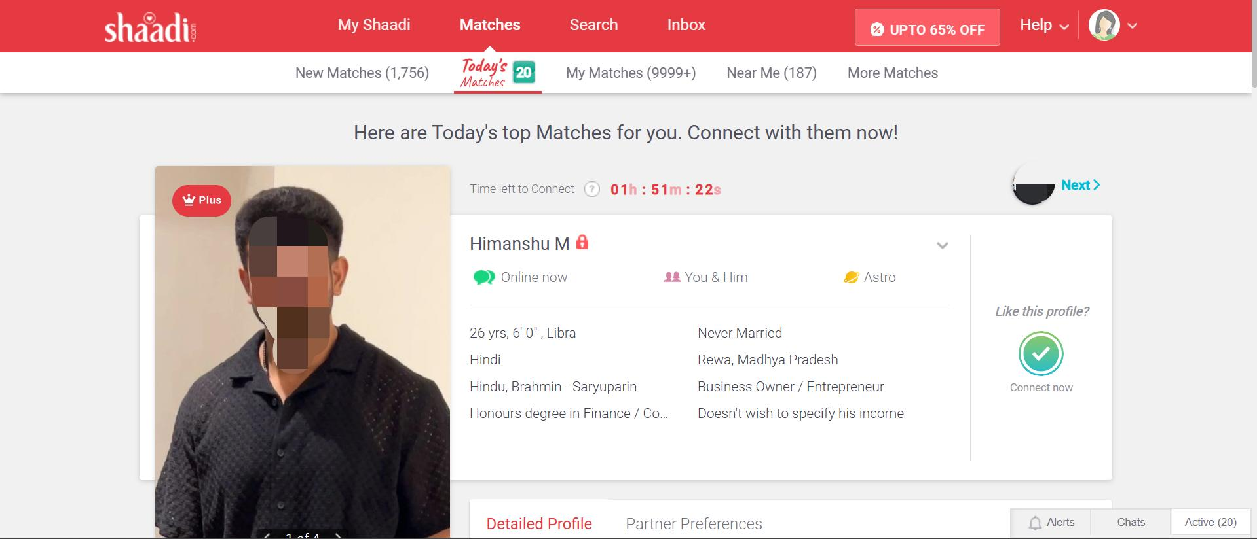

USABILITY
The ease with which users can discover suitable profiles and complete matchmaking tasks efficiently.
Website | Rating | Points
Shaadi.com | 8.5/10 | 1. Search results can be narrowed using multiple personal and partner-preference criteria.  2. Profile pages present key details before a user decides whether to connect.  3. Users can shortlist profiles and revisit them later.  4. Comparing several profiles side-by-side is not always immediate and may require moving between profiles.

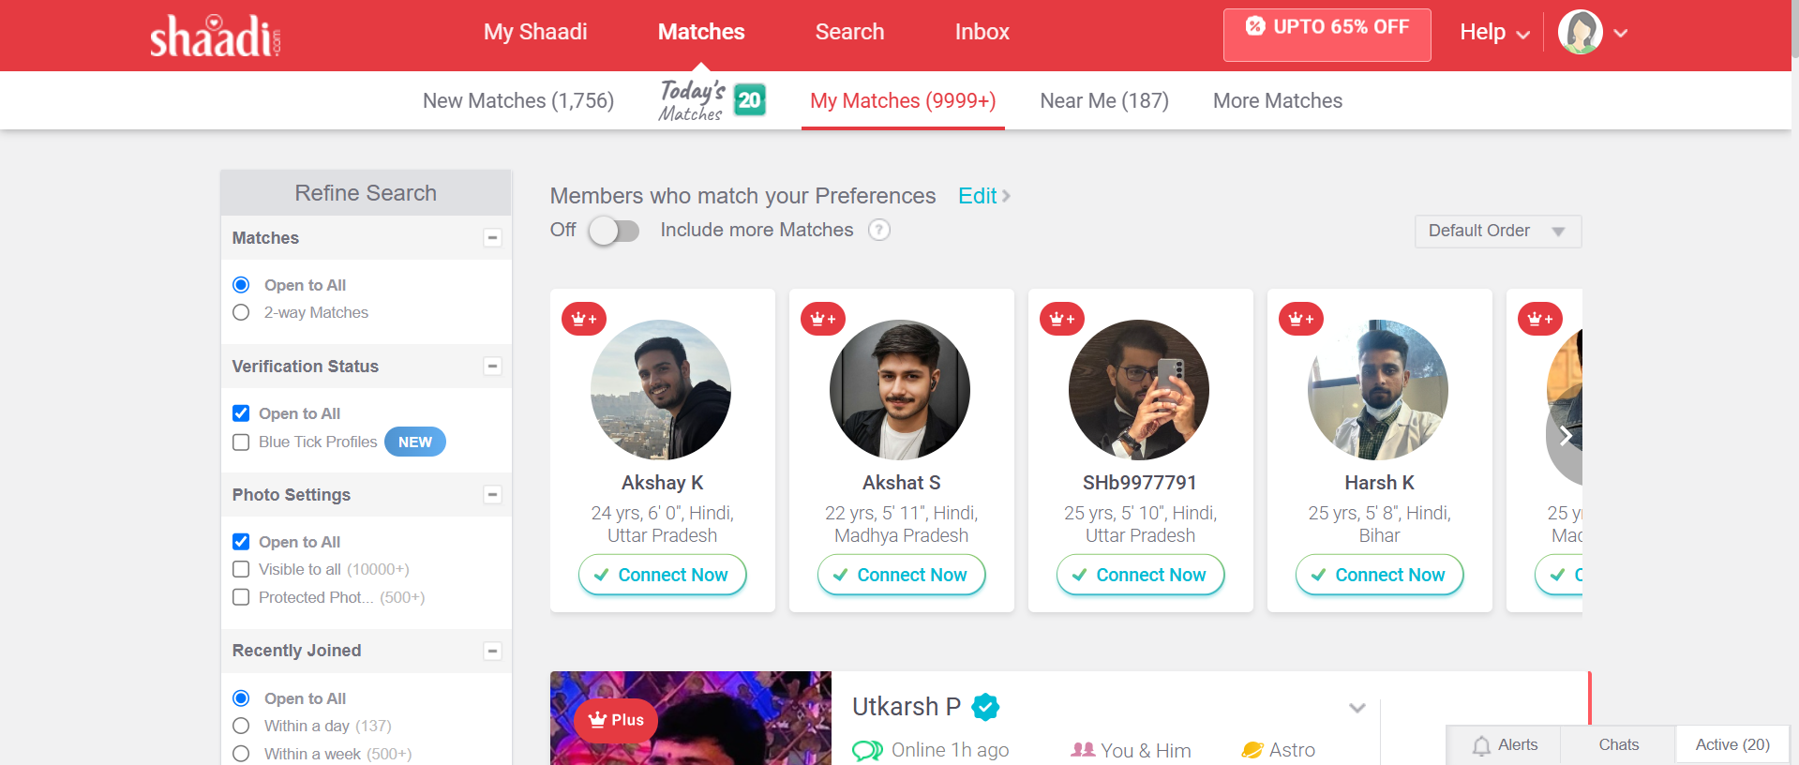

ERROR PREVENTION AND RECOVERY
How well the interface helps users avoid mistakes and recover from them.
Website | Rating | Points
Shaadi.com | 8/10 | 1. Search forms make required matchmaking criteria explicit.  2. Users can refine or reset search criteria rather than starting over.  3. Saved searches allow users to return to previously defined criteria.  4. Very specific combinations of preferences can make the interface feel complex and may require users to revise filters.

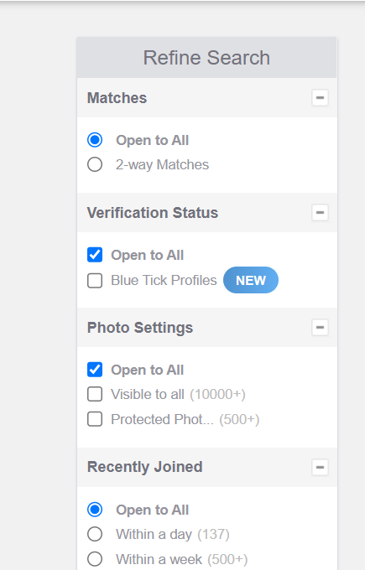

USE OF METAPHORS
Using familiar real-world icons and symbols to help users understand and navigate the interface easily.
Website | Rating | Points
Shaadi.com | 9/10 | 1. Search/magnifying-glass imagery communicates finding profiles.  2. Profile photos act as a familiar representation of a person.  3. Shortlist/interest actions use recognizable social interaction patterns.  4. Verification indicators communicate trust and authenticity at a glance.  5. These metaphors reduce the amount of explanation required for common actions.

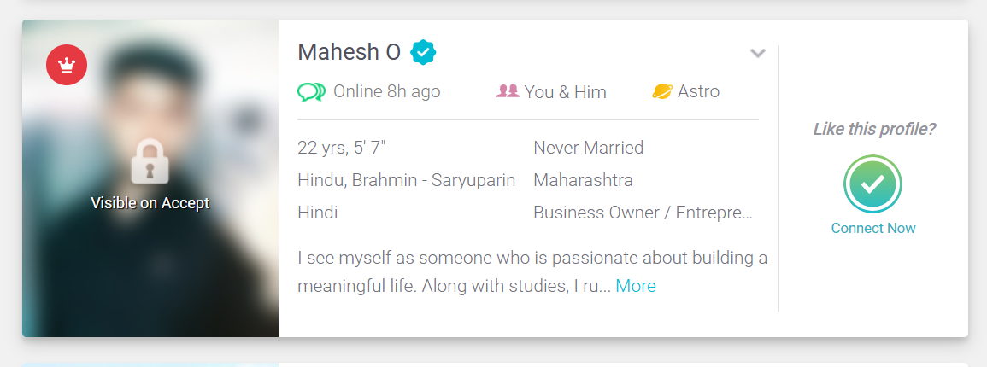
NAVIGATION STRUCTURE
Clarity and organization of menus, filters, links and information hierarchy.
Website | Rating | Points
Shaadi.com | 8/10 | 1. Core matchmaking actions such as Search and Matches are easy to identify.  2. Search filters are grouped around meaningful partner criteria.  3. Users can refine results without abandoning the overall discovery task.  4. The number of search modes and advanced criteria can make exploration lengthy for first-time users.
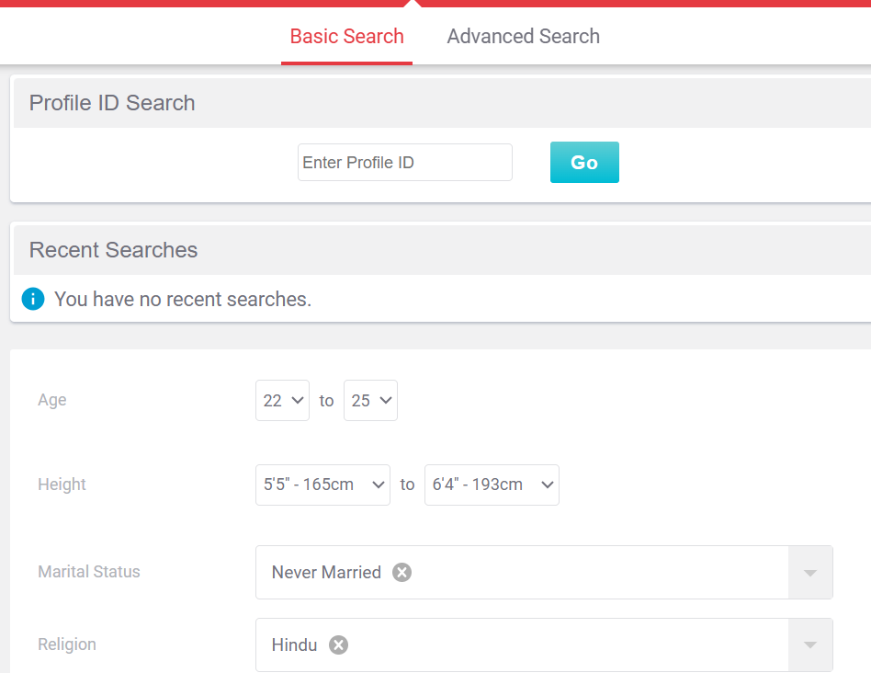

VISUAL HIERARCHY
How effectively size, spacing, contrast and emphasis guide user attention.
Website | Rating | Points
Shaadi.com | 7.5/10 | 1. Profile photos naturally attract attention first.  2. Age, location, religion/community and other key facts are important scanning anchors.  3. Verification indicators add useful emphasis and support trust.  4. Multiple labels, badges, preference details and promotional elements can compete with the main decision-making information.

8 GOLDEN RULES OF INTERFACE DESIGN

Golden Rule | Shaadi.com
1. Strive for consistency | Search controls, profile information and common matchmaking actions should remain consistent across pages.
2. Seek universal usability | The core search concept is understandable to a broad audience, though extensive matrimonial criteria can overwhelm some users.
3. Offer informative feedback | Searches, saved searches, shortlist actions and profile interactions should clearly communicate the resulting state.
4. Design dialogs to yield closure | Matchmaking actions should lead users toward a clear next step such as viewing a profile, shortlisting, expressing interest or communicating.
5. Prevent errors | Search fields, filters and profile settings reduce incomplete or unsuitable searches, although overly specific preferences may create confusion.
6. Permit easy reversal of actions | Users can reset or refine searches and manage shortlisted or ignored profiles rather than being locked into one discovery path.
7. Keep users in control | The extensive search and refinement criteria give users substantial control over the profiles they see.
8. Reduce short-term memory load | Important profile attributes appear together, but the number of attributes can still increase cognitive load.

MAJOR UI/UX PROBLEMS IDENTIFIED
1. Information Overload
Profile cards and profile pages can contain photos, age, height, religion, community, education, profession, location, verification indicators and other preference information. This can make rapid scanning harder.
2. Filter Overload
The wide range of basic and advanced search criteria gives users control but can overwhelm first-time users who do not know which filters matter most.
3. Difficult Profile Comparison
Users may need to open profiles one at a time to compare important attributes. A lightweight comparison view could reduce memory load.
4. Promotional and Trust Elements Competing for Attention
Verification badges and membership-related prompts are useful, but too many secondary elements can compete with the user's primary task.
5. Dense Preference Information
Matrimonial profiles often contain many personal, family and partner-preference attributes. Presenting all of them with equal visual weight can make the interface feel text-heavy.
6. Complex Decision Flow
A user may move from Matches to Search to a profile to Shortlist/Interest and then to communication. Clearer progression and stronger contextual actions could reduce navigation effort.

OVERALL EVALUATION
Shaadi.com — Overall Rating: 8.3/10
Shaadi.com provides a strong matrimonial-search experience, particularly in search and discoverability, familiar interaction patterns, personalization and trust-oriented presentation. Its Basic and Advanced Search options allow users to define detailed partner preferences, while matching and shortlist features support an ongoing discovery process.
The main design weakness is information density. A matrimonial profile can contain many attributes, and the extensive filtering system can increase cognitive load. Promotional elements and trust indicators can also compete with the information users need to make a decision.
A simpler presentation, progressive disclosure for advanced filters, easier profile comparison and stronger visual prioritization of match-relevant information would make the interface more efficient without removing its powerful matchmaking features.

CONCLUSION
Shaadi.com is a feature-rich matrimonial interface that balances profile discovery, detailed partner preferences, personalized matching and trust signals. Its strongest UX qualities are search flexibility, recognizable interaction patterns and personalization.
However, the same feature richness creates the main usability challenge: users can be presented with too many filters, attributes, badges and actions at once. The interface would benefit from a stronger information hierarchy and progressive disclosure, allowing users to begin with a simple search and reveal more detailed controls only when needed.
Overall, Shaadi.com demonstrates good learnability, usability and trust, but its interface could become more efficient and less cognitively demanding through simpler profile cards, better comparison tools and a more focused presentation of match-relevant information.

FINAL SCORE: 8.3 / 10

